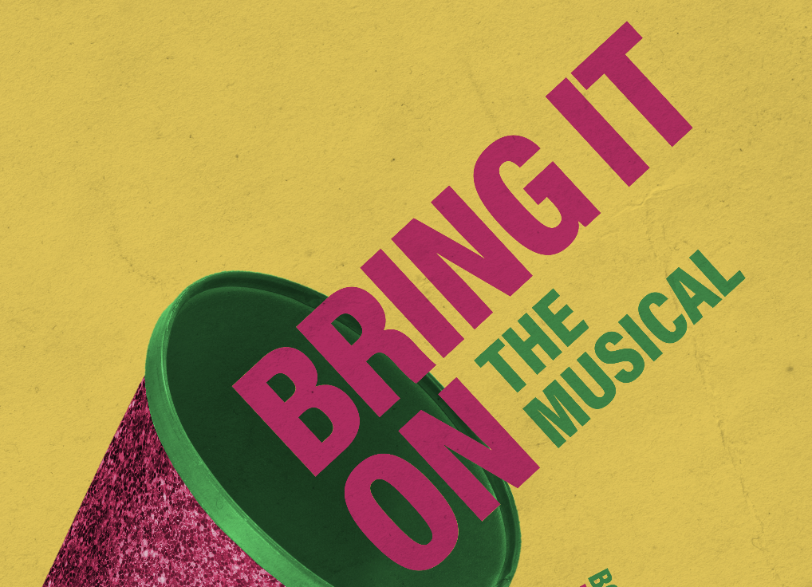 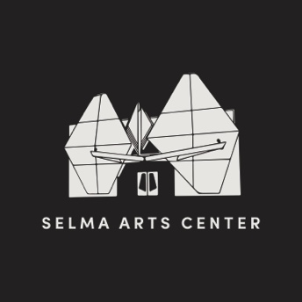

OPEN CALL AUDITION

**BRING IT ON THE MUSICAL**

Saturday, April 21st, 2018 at 9AM

Sunday, April 22nd, 2018 at 9AM **Dance Call: 1pm**

Callbacks – Monday, April 23rd at 6pm

**Auditions (Saturday, April 21st):** Performers are welcomed to make an appointment via Sign Up Genius (LINK). Those without an appointment will be seen as time permits. Please come prepared with 16-32 bars of a musical selection. You must have sheet music for a provided accompanist, or accompanying tracks. If you’re a dancer, gymnast, possess rap skills or have cheerleading experience please indicate so on the audition form.

BRING IT ON THE MUSICAL is rated PG-13. We welcome ages 16 and up with a parent release form to audition due to some mature content and language.

**Video Auditions:** If you are unable to make the general auditions (we strongly recommend an in-person audition), an accompanied video recording of your audition

song, with a scale run for range, may be submitted before Monday April 23rd to

michaelchristopherchoreography@gmail.com. Please send via unlisted YouTube link.

You MUST attend callbacks on Monday April 23rd in order to be considered for a role. If this is not possible, please message michaelchristopherchoreography@gmail.com with any questions or concerns.

**Audition Day Two (Sunday April 22nd):** Those who choose to audition the second day (Sunday April 22nd) please note that time slots will only be available until 12:30 pm. At 1pm, Dancers and Cheerleaders who are auditioning to be considered as a Dancer/Cheerleader **ONLY**, MUST attend the Dance Call at 1:00 pm stretched and warmed up to begin a dance audition.

**Callbacks:** Those considered for principle roles and dancers will go through a heavy dance call. “Dancers only” will be excused to read scenes, and sing.

**PRODUCTION INFORMATION**

• Audition forms, tentative schedules, video submission forms and parental consent forms are available online and will be available at the audition

• Due to the tight rehearsal schedule, all conflicts must be presented during your auditions. Conflicts presented after the first rehearsal will not be honored. Please note that excessive conflicts will affect casting decisions

• PERFORMANCE CONFLICTS WILL **NOT** BE ACCEPTED

• Casting notification will occur no later than **Tuesday, May 1st**

• Some extra music rehearsals may be called for principle roles. Should you be

cast, you will be contacted by the vocal director for your availability and scheduling.

**PLEASE NOTE** May 14-18 and 21st - 25th is **CHEER CAMP** where you will learn cheer

basics and stunts from 6-9 pm. Location is TBA.

• Rehearsals in June will be held Monday through Friday from 6:30pm – 9:30pm.

Some Saturday rehearsals will be scheduled with ample notice. First company meeting is scheduled for **Friday, May 4th** at the Selma Arts Center.

• Communication will be done through email and Facebook groups- please list a

valid email clearly and legibly on the audition form.

• Performances: July 19-28

If you have any additional questions about auditions or the production, please call Nicolette C. Andersen (559) 891-2238 or email [nicolettea@cityofselma.com](mailto:nicolettea@cityofselma.com).

This production is sponsored by the Selma Arts Council

**Directed and Choreographed by Michael C. Flores**

**Producer – Juan Luis Guzmán**

**Stage Manager - Alex Figueroa**

**Assistant Stage Manager - Sami Valles**

**Vocal Director - Mindy Ramos and Jeremy Hitch**

**Assistant Choreographer – William Davis**

**Graphic Designer & Promotions– Dominic Grijalva**

THE SELMA ARTS CENTER

1935 High St.

Selma, CA 93662

(559) 891-2238

Selmaartscenter.com

nicolettea@cityofselma.com

**AVAILABLE ROLES**

Campbell

A senior head cheerleader whose world gets turned upside-down when she transfers schools. She is constantly working towards the goal of a championship and her "one perfect moment". After using her friends to exact revenge, she realizes that friendship is much more lasting than a trophy.

Range: G3-F5

Danielle

The head of the Jackson dance crew. She has fought her way from nothing to make a name for herself, which leads her to not put a lot of stock into people like Campbell. But she has a tendency to bring down her walls and embrace a true friendship.

Range: F#3-F5

Nautica

One of the Jackson dance crew. Not the sharpest person on the squad, but is loud enough to make up for it.

Range: F3-Fb5

Randal

Jackson's school DJ, mellow and friendly. A true Cinderella story, working his way from a dorky freshman to a smooth senior. He becomes attracted to Campbell for her heart, bravery, and determination.

Range: C#3-A4

La Cienega

One of the Jackson dance crew, a male to female transgendered. Fashionable and mouthy, he has owned his unique identity and professes a message of selflove.

Range: D3-E5

Steven

The only male cheerleader on the Buccaneers and Campbell's boyfriend. Tender and comforting, but not the most adept to his surroundings.

Range: D3-Bb4

Kylar

One of the Buccaneers cheerleaders. An extremely loyal follower of Skylar who keeps her intelligence hidden under a bushel.

Range: G3-D5

Eva

Campbell's neighbor and the newest member of the Buccaneers cheerleaders. Her initial impression is one of naiveté and meekness. But she proves to be a social climber who schemes to take over Campbell's life at any cost.

Range: A3-Eb5

Twig

One of the Jackson students and a hip-hop artist. His hormones make him lust after Bridget.

Range: Eb3-A4

Bridget

The mascot for the Buccaneers. Nerdy and out of shape, but she strives for a place on the cheerleading team. Despite being an outcast, she has a good heart and a great spirit.

Range: A3-F5

Skylar

One of the senior Buccaneers cheerleaders. Her popularity has given her quite the mean streak, though she does not have the brains to make up for it.

Range: G3-Gb5

Cameron

One of the Jackson students, a hip-hop artist. A combination class clown and attempted ladies' man, but he strives for fame and fortune.

Range: Db3-G4

Ensemble: Cheerleaders and Dancers